Jacobi Polynomials for Orthogonal Collocation

<https://demonstrations.wolfram.com/JacobiPolynomialsInAnOrthogonalCollocationMethod/>

(Refer Eq (8) in Villadsen and Stewart, 1967, Chem Eng Sci, pp 1483)

Cylindrical Geometry

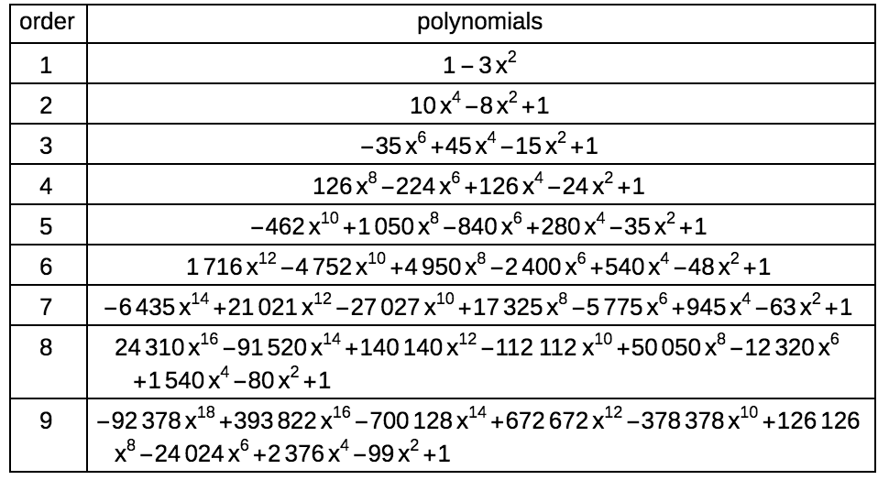

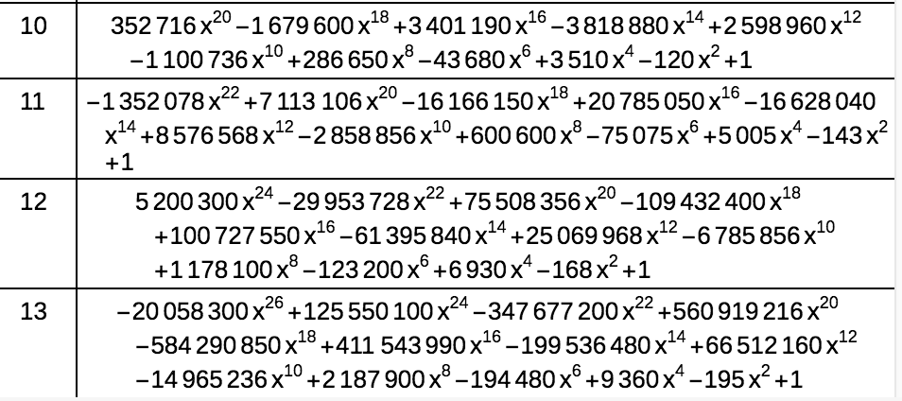

Interior Points: Roots of polyniomial

n=5,

roots([-462,0,1050,0,-840,0,280,0,-35,0,1])

x=[0.199524076370, 0.444986986185, 0.661796653246, 0.833945006193, 0.949455061707,1];

From Eq. (C.4), Villadsen and Stewart, 1967, Chem Eng Sci, pp 1483

Q=[1,x(1)^2,x(1)^4,x(1)^6,x(1)^8,x(1)^10;1,x(2)^2,x(2)^4,x(2)^6,x(2)^8,x(2)^10;1,x(3)^2,x(3)^4,x(3)^6,x(3)^8,x(3)^10;1,x(4)^2,x(4)^4,x(4)^6,x(4)^8,x(4)^10;1,x(5)^2,x(5)^4,x(5)^6,x(5)^8,x(5)^10;1,x(6)^2,x(6)^4,x(6)^6,x(6)^8,x(6)^10]

|  |  |  |  |  |  |
| --- | --- | --- | --- | --- | --- |
| 1 | 0.03980986 | 0.00158482 | 6.31E-05 | 2.51E-06 | 1.00E-07 |
| 1 | 0.19801342 | 0.03920931 | 0.00776397 | 0.00153737 | 0.00030442 |
| 1 | 0.43797481 | 0.19182193 | 0.08401318 | 0.03679565 | 0.01611557 |
| 1 | 0.69546427 | 0.48367056 | 0.33637559 | 0.23393721 | 0.16269497 |
| 1 | 0.90146491 | 0.81263899 | 0.73256554 | 0.66038213 | 0.59531132 |
| 1 | 1 | 1 | 1 | 1 | 1 |

From Eq. (C.1), Villadsen and Stewart, 1967, Chem Eng Sci, pp 1483

Qin = inv(Q)

|  |  |  |  |  |  |
| --- | --- | --- | --- | --- | --- |
| 1.59119149 | -1.0260165 | 0.77116761 | -0.5907337 | 0.42105775 | -0.1666667 |
| -17.313107 | 31.7550429 | -26.001276 | 20.4170039 | -14.690997 | 5.83333333 |
| 66.3303372 | -162.82705 | 183.550738 | -156.72374 | 116.336386 | -46.666667 |
| -115.95573 | 326.835324 | -444.61801 | 436.270492 | -342.53208 | 140 |
| 94.6127467 | -288.59954 | 442.338793 | -489.17841 | 415.826413 | -175 |
| -29.265439 | 93.8622435 | -156.04142 | 189.805392 | -175.36078 | 77 |

RHSC1T1=[0,2*x(1),4*x(1)^3,6*x(1)^5,8*x(1)^7,10*x(1)^9;0,2*x(2),4*x(2)^3,6*x(2)^5,8*x(2)^7,10*x(2)^9;0,2*x(3),4*x(3)^3,6*x(3)^5,8*x(3)^7,10*x(3)^9;0,2*x(4),4*x(4)^3,6*x(4)^5,8*x(4)^7,10*x(4)^9;0,2*x(5),4*x(5)^3,6*x(5)^5,8*x(5)^7,10*x(5)^9;0,2*x(6),4*x(6)^3,6*x(6)^5,8*x(6)^7,10*x(6)^9]

|  |  |  |  |  |  |
| --- | --- | --- | --- | --- | --- |
| 0 | 0.39904815 | 0.0317721 | 0.00189726 | 0.00010071 | 5.01E-06 |
| 0 | 0.88997397 | 0.35245358 | 0.10468581 | 0.02763893 | 0.0068411 |
| 0 | 1.32359331 | 1.15940105 | 0.76168269 | 0.44479711 | 0.24351241 |
| 0 | 1.66789001 | 2.31991583 | 2.42012787 | 2.24414996 | 1.95090765 |
| 0 | 1.89891012 | 3.4236017 | 4.62938522 | 5.56430447 | 6.27003157 |
| 0 | 2 | 4 | 6 | 8 | 10 |

From Eq. (C.1), Villadsen and Stewart, 1967, Chem Eng Sci, pp 1483

A=RHSC1T1*Qin

|  |  |  |  |  |  |
| --- | --- | --- | --- | --- | --- |
| -5.0119265 | 8.0899333 | -5.3437622 | 3.94733349 | -2.7750403 | 1.09346213 |
| -1.7539821 | -2.2472567 | 6.1657355 | -3.6178015 | 2.36365824 | -0.9103534 |
| 0.62345726 | -3.3179072 | -1.5110382 | 6.25264479 | -3.2092731 | 1.16211637 |
| -0.3922283 | 1.65805759 | -5.3252413 | -1.1991198 | 7.48036443 | -2.2218326 |
| 0.3677846 | -1.4448698 | 3.64561974 | -9.9772744 | -1.0532357 | 8.46197565 |
| -0.791657 | 3.03992661 | -7.211463 | 16.1886102 | -46.225417 | 35 |

From Eq. (11), Villadsen and Stewart, 1967, Chem Eng Sci, pp 1483

$x^{1-a}\frac{d}{dx}\left(x^{a-1}\frac{dy}{dx}\right)$ is the Laplacian operator shown in Eq (C.2) to compute B. With $a=2$, for cylinder the Laplacian operator is $x^{-1}\frac{d}{dx}\left(x\frac{dy}{dx}\right)$

Thus,

RHSC2T1=[

0,4,16*x(1)^2,36*x(1)^4,64*x(1)^6,100*x(1)^8;

0,4,16*x(2)^2,36*x(2)^4,64*x(2)^6,100*x(2)^8;

0,4,16*x(3)^2,36*x(3)^4,64*x(3)^6,100*x(3)^8;

0,4,16*x(4)^2,36*x(4)^4,64*x(4)^6,100*x(4)^8;

0,4,16*x(5)^2,36*x(5)^4,64*x(5)^6,100*x(5)^8;

0,4,16*x(6)^2,36*x(6)^4,64*x(6)^6,100*x(6)^8;

]

|  |  |  |  |  |  |
| --- | --- | --- | --- | --- | --- |
| 0 | 4 | 0.63695771 | 0.05705369 | 0.00403787 | 0.00025117 |
| 0 | 4 | 3.16821469 | 1.41153529 | 0.49689409 | 0.15373703 |
| 0 | 4 | 7.00759696 | 6.90558964 | 5.37684322 | 3.67956545 |
| 0 | 4 | 11.1274284 | 17.41214 | 21.5280379 | 23.3937206 |
| 0 | 4 | 14.4234386 | 29.2550037 | 46.8841945 | 66.0382131 |
| 0 | 4 | 16 | 36 | 64 | 100 |

B=RHSC2T1*Qinv

|  |  |  |  |  |  |
| --- | --- | --- | --- | --- | --- |
| -33.243827 | 40.8116344 | -10.711231 | 4.80489751 | -2.5703434 | 0.90887007 |
| 19.7340493 | -56.4846 | 45.7352248 | -12.944994 | 5.98077998 | -2.0204597 |
| -4.1450351 | 36.6022191 | -83.883267 | 64.281922 | -18.329506 | 5.47366729 |
| 1.99554408 | -11.118516 | 68.9885841 | -156.65838 | 121.129964 | -24.337193 |
| -1.6210429 | 7.80061719 | -29.872069 | 183.940665 | -486.39659 | 326.148419 |
| -53.701388 | 203.712733 | -467.9005 | 952.94662 | -1451.7241 | 816.666667 |

Rectangular Geometry

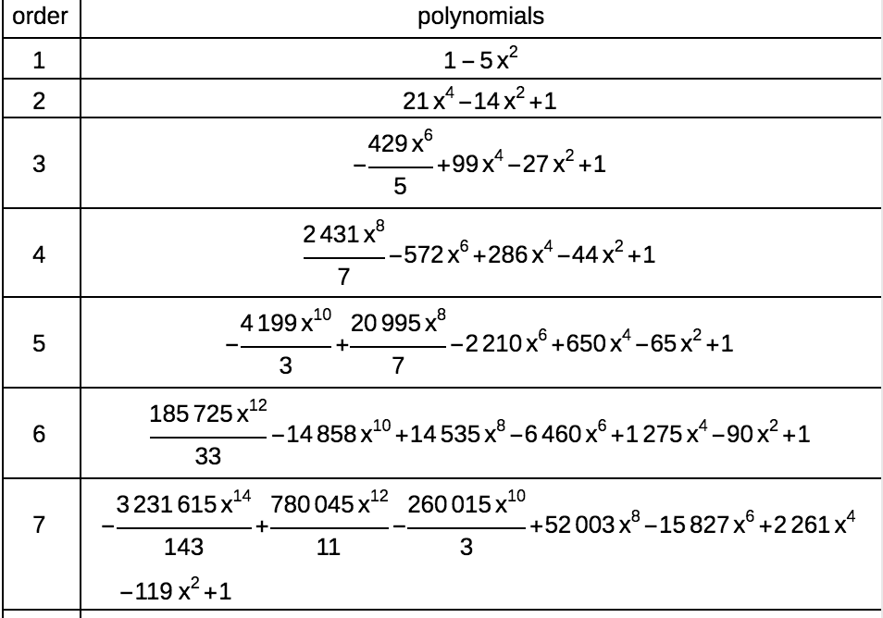

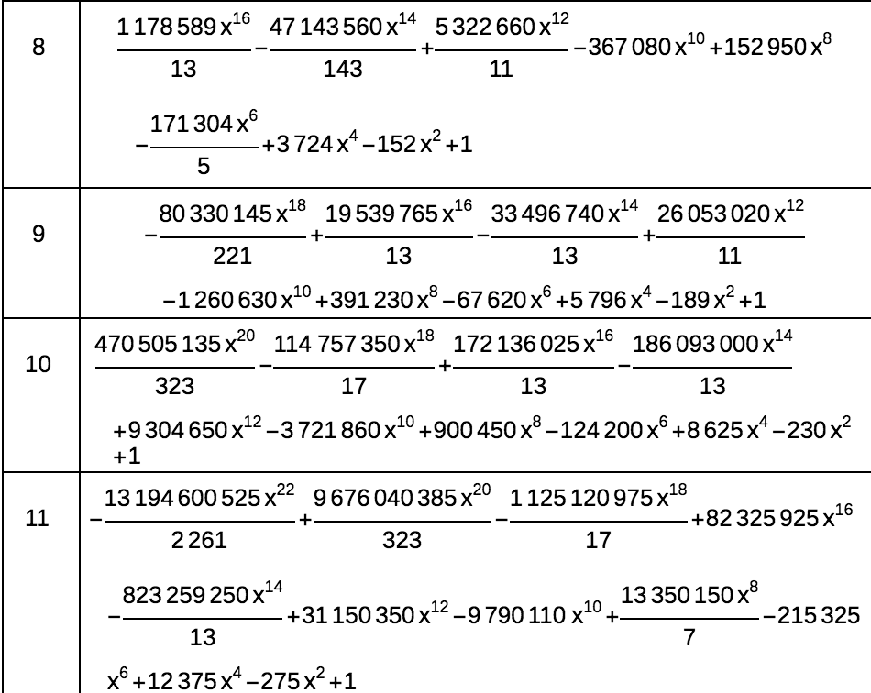

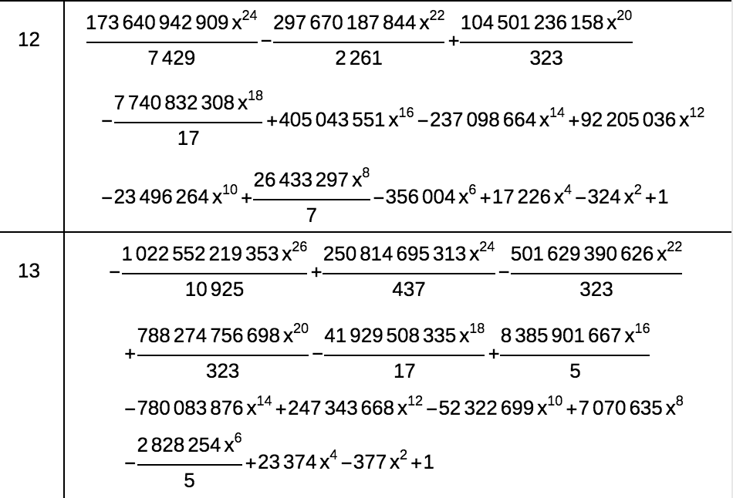

Spherical Geometry

